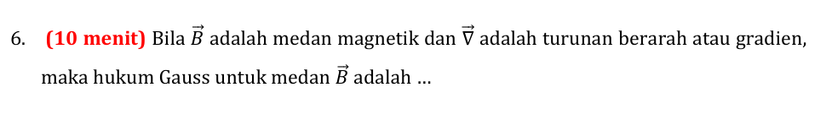
Hukum Maxwell:
$$∇⋅\vec{B}=0$$

$$\int_{0}^{V}{∇⋅\vec{B} dV=∮\vec{B}⋅dA}$$
$$0=∮\vec{B}⋅dA$$

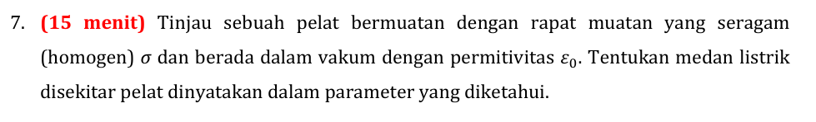
$$σ=\frac{q}{A}$$
Dicari E=?
Hukum gauss:
$$∮\vec{E}⋅dA=\frac{q}{ϵ_{0}}$$
$$E.A=\frac{q}{ϵ_{0}}$$
$$E=\frac{q}{A.ϵ_{0}}$$
$$E=\frac{σ}{ϵ_{0}}$$

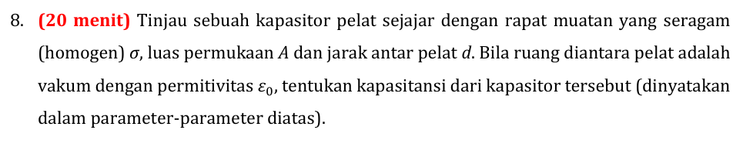
DIketahui: $σ, A, d, ϵ_{0}$
Ditanya: C=?
$$q=CV$$
$$C=\frac{q}{V}$$
Mencari q:
$$q=σ.A$$
Mencari V:
$$V=E.d$$
Mencari E: (Hukum Gauss)
$$∮\vec{E}⋅dA=\frac{q}{ϵ_{0}}$$
$$E.A=\frac{q}{ϵ_{0}}$$
$$E=\frac{q}{ϵ_{0}.A}$$

$$V=\frac{q.d}{ϵ_{0}.A}$$
$$V=σ.\frac{d}{ϵ_{0}}$$

Menghitung C:
$$C=\frac{q}{V}$$
$$q=σ.A$$
$$V=\frac{q.d}{ϵ_{0}.A}$$
$$C= A.\frac{ϵ_{0}}{d}$$

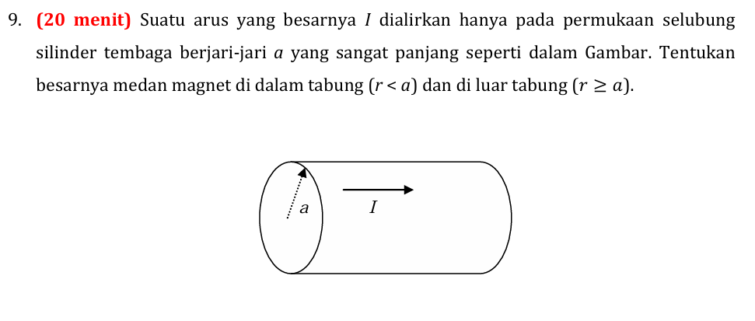
‘I’ arus hanya pada permukaan.
Diketahui: I, jari-jari(a).
Dicari: B pada r<a dan r>=a.

Rumus Hukum Ampere:
$$∮\vec{B}⋅dl=μ_{0}I$$
Tinjau pada r<a:
$$∮\vec{B}⋅dl=μ_{0}I$$
$$B.2πr=μ_{0}I$$
$$B.2πr=μ_{0}0$$
$$B=0$$
Tinjau pada r>=a:
$$∮\vec{B}⋅dl=μ_{0}I$$
$$B.2πr=μI$$
$$B=\frac{μI}{2πr}$$

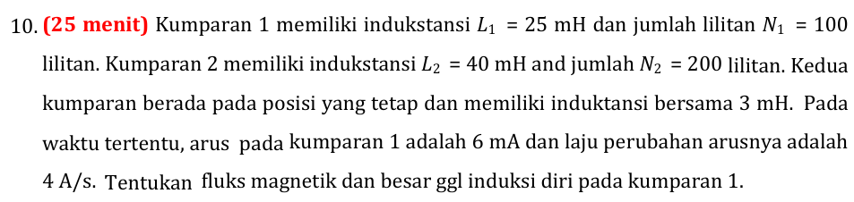

Diketahui:
I = 6 mA
L1 = 25 mH = 0,025 H
N1 = 100 lilitan
dI/dt = 4 A/s

Dicari:
Fluks ($ϕ_{b}$)=?
GGL($ε$)=?

Rumus GGL:
$$ε=-\frac{Ndϕ_{b}}{dt}=-\frac{LdI}{dt}$$

Menghitung GGL:
$$ε=-\frac{LdI}{dt}$$
$$ε=-0,025.4=-0,1 volt$$

Mencari fluks:
$$-\frac{Ndϕ_{b}}{dt}=-\frac{LdI}{dt}$$
$$Ndϕ_{0}=LdI$$
$$\int_{0}^{ϕ_{0}}{ Ndϕ_{0}}=\int_{0}^{I}{LdI}$$
$$N.ϕ_{0}=L.I$$
$$ϕ_{0}=L.\frac{I}{N}=\frac{0,025.0,006}{100}=1,5×{10}^{-6} Wb$$

